William Colon

4-2 Milestone Three:

Enhancement Two: Algorithms and Data Structure

I decided to use C++ for this artifact because I am not a developer and I do not have a lot of expertise in coding. Secondly, the best instructions I found were for C++, at least for me. This artifact was selected from one of my previous classes, which was CS-320 Software Development Life Cycle. It is about making an appointment. Because it demonstrates my expertise in algorithms and data structures, specifically through the design of an effective sorting algorithm and the optimization of a data retrieval process utilizing a balanced tree structure, I decided to include this artifact in my ePortfolio. I did this because it represents my competency in these areas. Through the completion of this project, I have demonstrated my proficiency in understanding the complexity of algorithms, selecting data structures that are suitable for particular tasks, and writing code that is both clean and functional. Through iterative testing and performance profiling, the artifact was improved, which resulted in a reduction in runtime complexity and greater scalability. All of these improvements were made possible. Taking everything into consideration, this project is a reflection of my analytical ability as well as my dedication to the ongoing advancement of writing processes.

As far as I was concerned, I had achieved all the goals that I had set for myself at the beginning of training and the Recommendations have been given to me. I've learned that there are a lot of different methods to include algorithms into the code, which is something that I find to be quite difficult. I am pleased to report that I was able to effectively meet the course outcomes that I had planned for Module One. I was able to demonstrate my comprehension of important algorithms and data structures by putting them into practice in my artifact. The learning objectives were nicely connected with the methodologies and tactics that I was able to examine and implement, which included effective sorting procedures and data management, respectively. Nevertheless, on the basis of my experiences and the feedback I received throughout this module, I intend to revise my outcome-coverage plans in order to incorporate a more in-depth investigation of graph algorithms and the applications they have in the real world.

Throughout the process of enhancing and modifying the artifact, I learned the importance of iterative development and the value of debugging and optimization techniques. Each revision deepened my understanding of how different algorithms perform under various conditions, highlighting the need to consider both time and space complexity in my choices. One significant challenge I faced was balancing code efficiency with readability; optimizing for performance sometimes led to less intuitive code. Additionally, troubleshooting unexpected behaviors in the data structure implementation taught me the necessity of thorough testing and the ability to adapt and revise strategies based on results. Ultimately, this experience reinforced my problem-solving skills and underscored the importance of planning and documenting changes throughout the development process.

First the info was embedded in the code

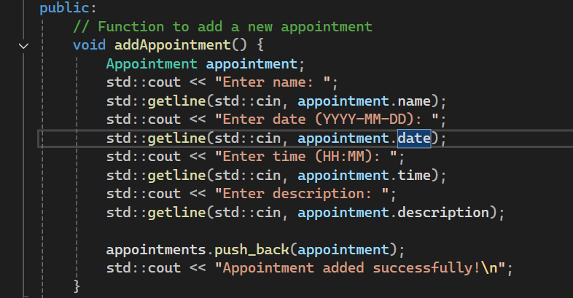

I restructured the function more structured

